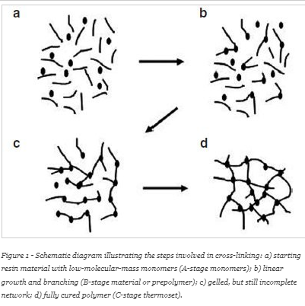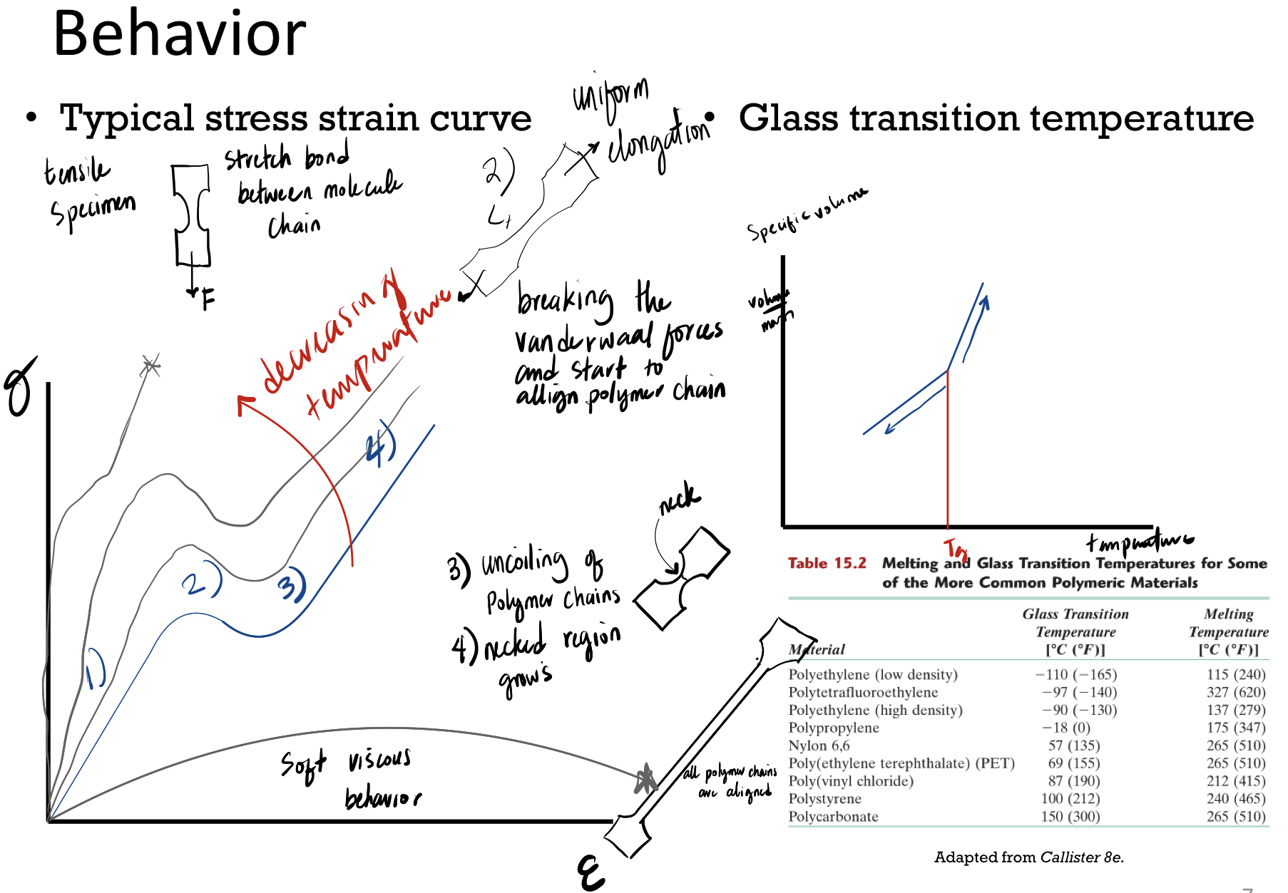**Springback**

Look up Ks from table.

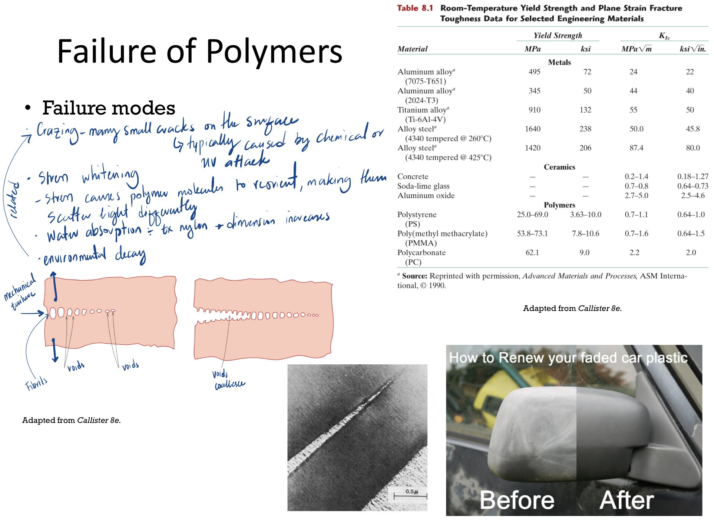Can’t look up Ks from table. Need material properties.

Limiting Drawing Ratio

$$LDR <\frac{D_{o}}{D_{p}}$$

Normal anisotropy/plastic anisotropy/strain ratio

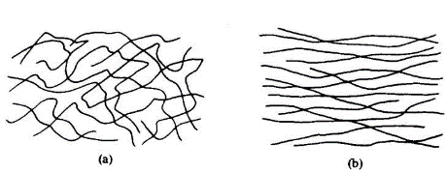

Planar anisotropy

Want a high for good LDR.

Low for good LDR

$$∆R= 0 →no earing(same in all directions)$$

$$∆R↑=height of ears increases$$

Desirable to have a larger die and punch radii.

Maximum punch force

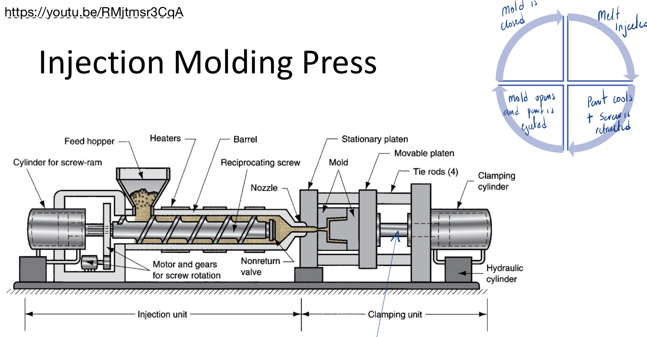

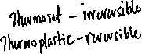

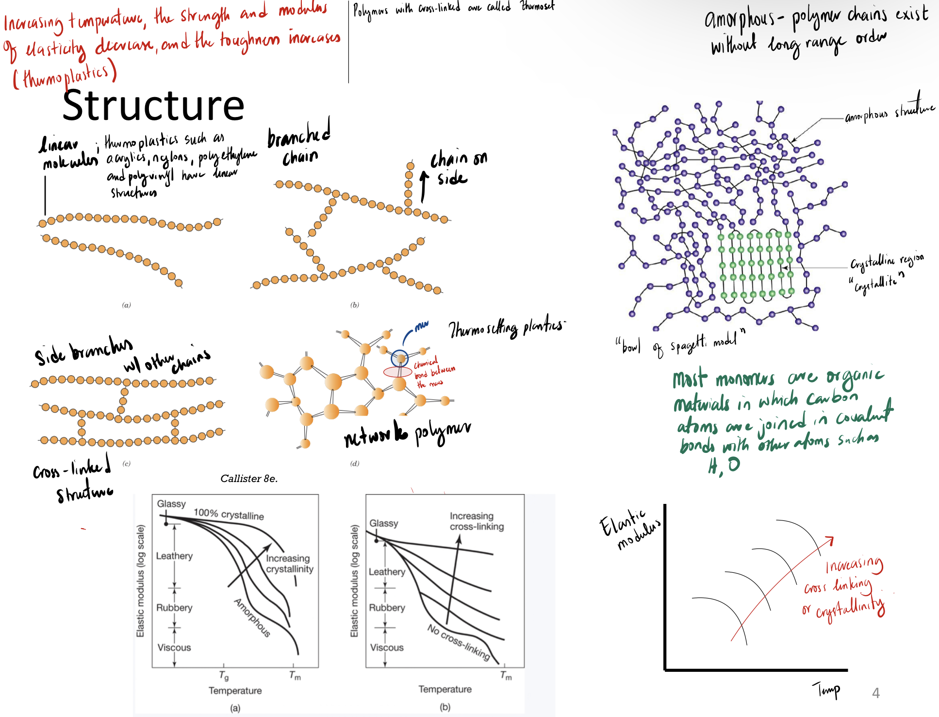**Polymer Properties**



**Polymer Processing**

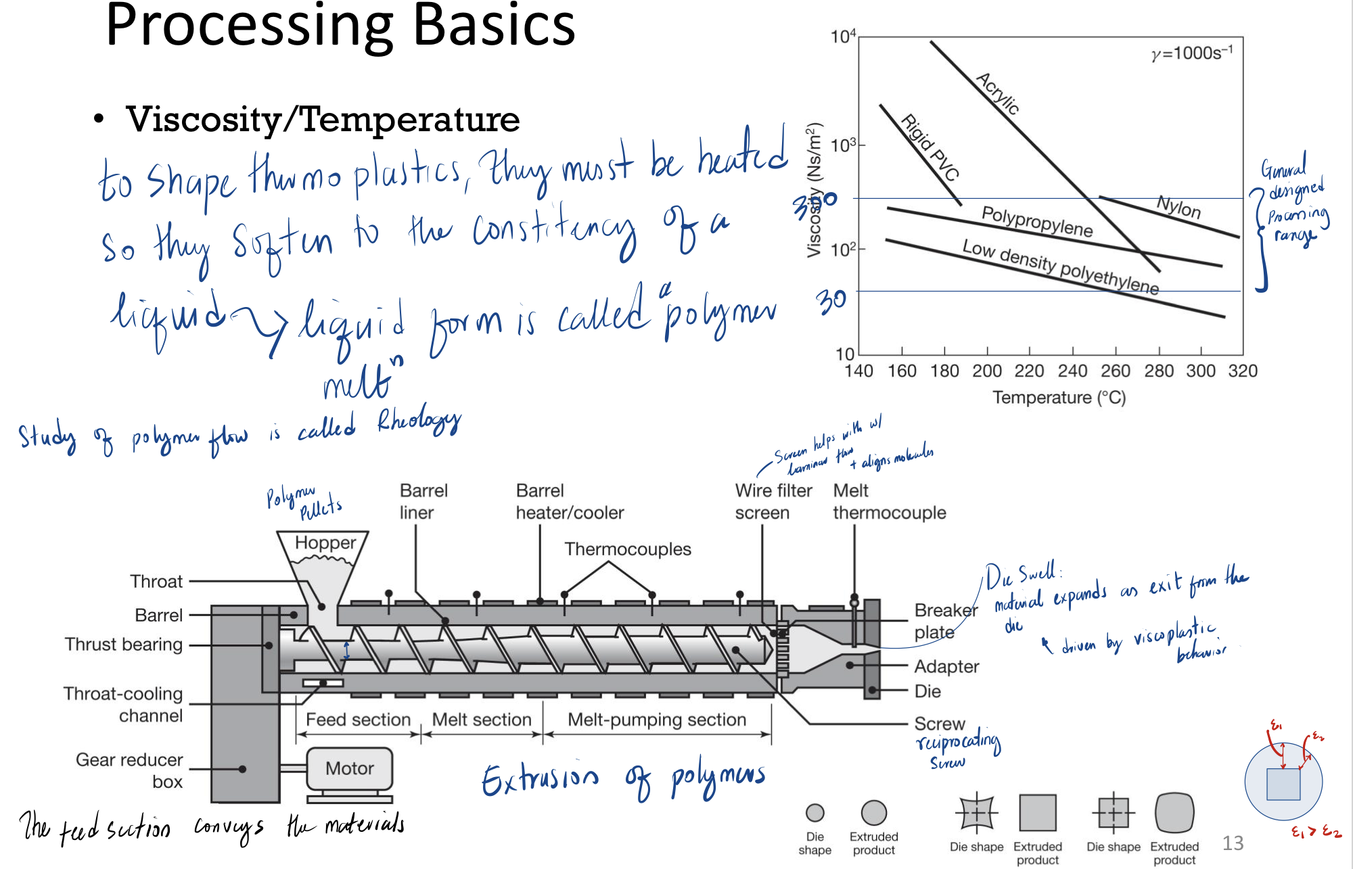

*Injection molding* is very similar to hot chamber die casting. The pellets or granules are fed into a heated cylinder, where they are melted, then forced into a split-die chamber, either by a hydraulic plunger or by the rotating screw of an extruder. Most modern equipment is of the *reciprocating-screw* type. As the pressure builds up at the mold entrance, the screw starts to move backward and under pressure, to a predetermined distance, thus controlling the volume of material to be injected. The screw then stops rotating and is pushed forward hydraulically, forcing the molten plastic into the mold cavity. Injection-molding pressures usually range from 70 to 200 MPa (10–30 ksi).

In *extrusion*, raw thermoplastic materials, in the form of pellets, granules, or powder, are placed into a hopper and fed into the extruder barrel. The barrel is equipped with a *screw* that blends and conveys the pellets down the barrel. The internal friction and shear stresses developed from the mechanical action of the screw, along with heaters around the extruder’s barrel, heats the pellets and liquefies them. The screw action also builds up pressure in the barrel.

*Blow molding* is a modified combination of extrusion and injection-molding processes. In **injection blow molding**, a short tubular preform (**parison**) is first injection molded. The parison can be stored for future molding, or it can be used immediately. If used immediately, the parison molds are opened, and the parison is transferred to a blow-molding die. Hot air is injected into the parison, which expands and fills the mold cavity. Typical products made include plastic beverage bottles and hollow containers.

**Shrink Rate**

Polymers have high thermal expansion coefficients, so significant shrinkage occurs during solidification.

$$D_{C}=D_{p}+D_{p}S+D_{p}S^{2}$$

$$D_{c}-dimension of cavity machined into mold$$

$$D_{p}-desired part dimension$$

$$D_{p}-desired part dimension$$

**Composites**

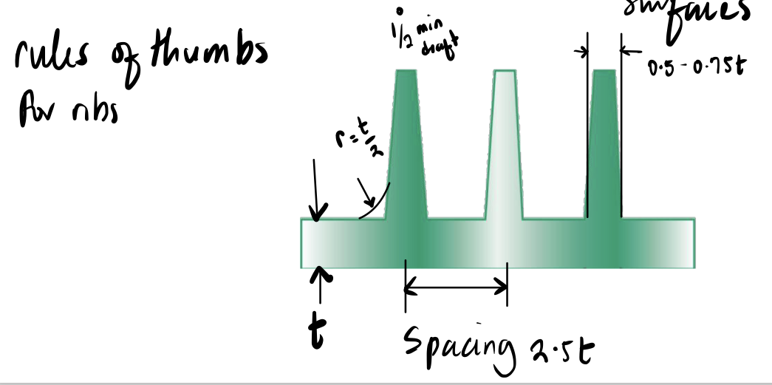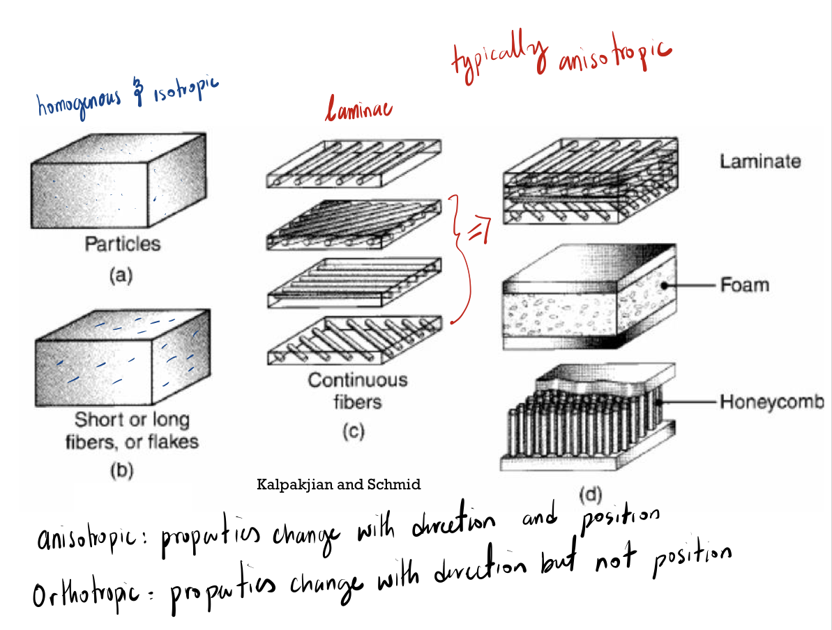A material system that is composed of two or more physically distinct phases that have different properties and constituents.

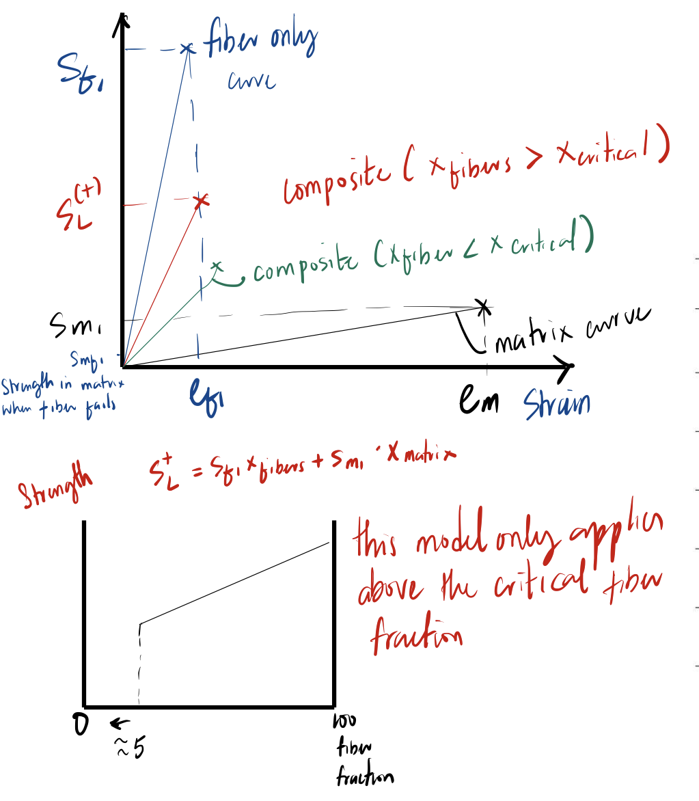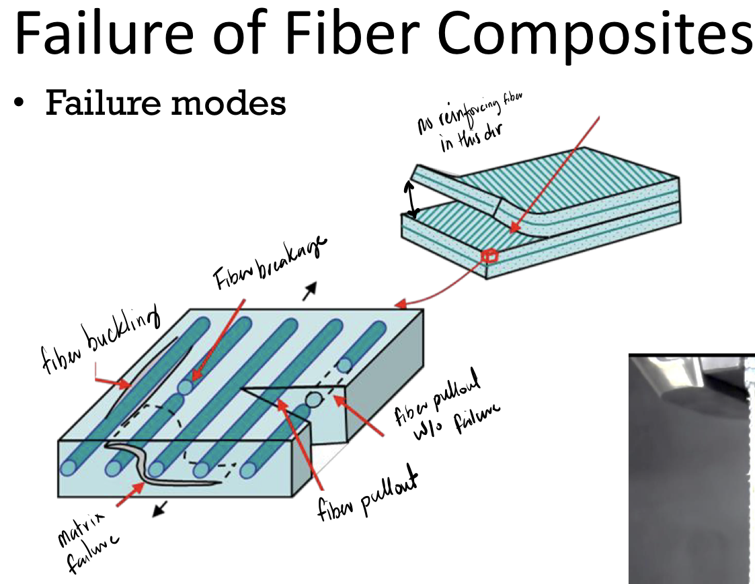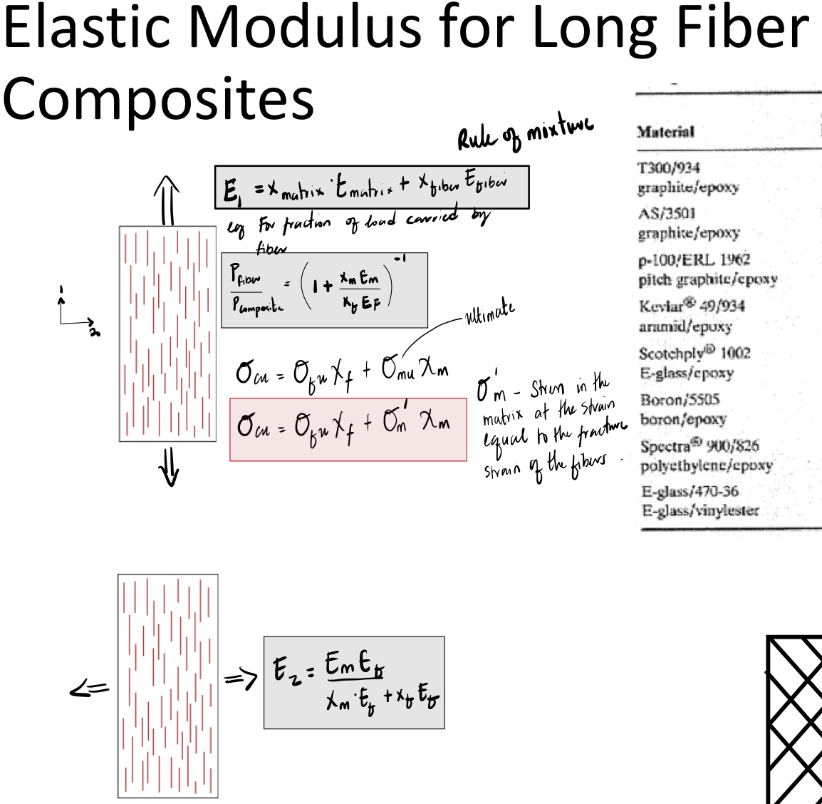

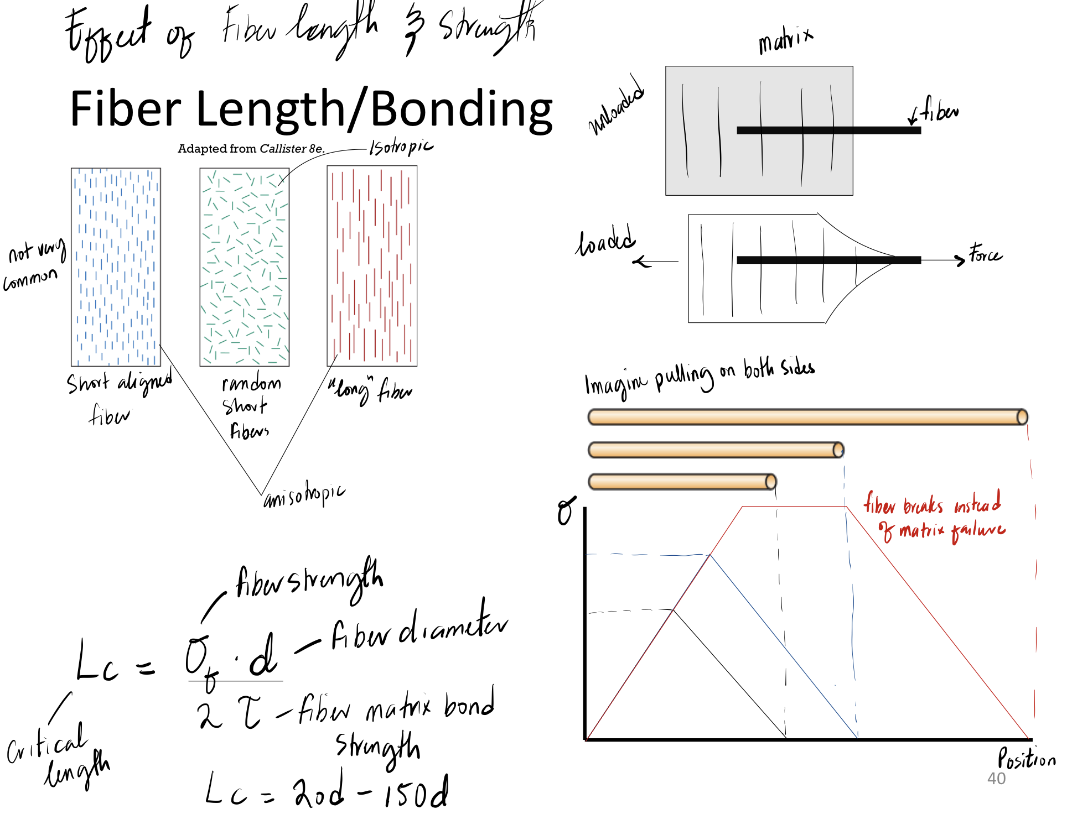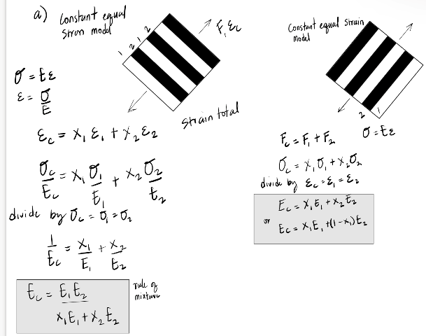



**Polymer Design**

* Wall Thickness
  + The basic wall of the part should be kept uniform.
  + Less than 5mm
  + Avoid variations in thickness to simplify flow patterns.
  + Avoid abrupt changes in wall thickness in wall thickness- use gradual transitions if necessary.
* Parting Lines
  + Specify mismatch on the  
    parting line.
* Ejection
* No undercuts
* Draft
  + Minimum draft - 1 degree
  + 1/2 degree on short surface or critical section
  + 5-12 degree for textured surfaces
* Appearance Parts Ribs/Gussets
  + The thickness of the rib at the intersection with the nominal wall should be 50 to 60% of the nominal wall.
* Bosses
  + Typically, the boss OD = 2 ID.
  + The wall thickness at the base of the boss should remain less than 60% of the nominal wall thickness.
  + The boss height should be  
    less than 3 × OD.
  + Draft on the OD is 1/2 ̊  
    minimum.
* Holes
  + For blind holes, the length  
    over diameter ratio should  
    remain below 2. As the diameter of the hole increases above 3/16 inch, the length over diameter ratio can increase to 3.
* Depressions
* Radii, Fillets and Corners
  + The outside corner radius  
    should be equal to the inside  
    radii plus the wall thickness  
    (R = r + t).

